|  |  |  |  |  |  |
| --- | --- | --- | --- | --- | --- |
| Date | 5-Dec-22 | | | Tester Name | Mohammad Yusuf |
| Environment | Penfax - Test | | | Login used |  |
| Operating System | Select OS | Version: | Update: | | |
| Software Used | Select Software | Version: | Update: | | |
| Select Software | Version: | Update: | | |
| Release version |  | | | | |
| Title | M17 Contributions & DCT | | | | |
| Test Type | Regression | | | | |
| Test Scenario | M17.06 Confirm can export to excel, pdf | | | | |
|  |  | | | | |
| Expected Results | File list on Dashboard and Transactions in File should be exported in Excel and PDF formats. | | | | |
| Pass/Fail | Pass | | | JIRA# | N/A |

Describe your steps with screenshots:

1. Log into MEPP DCT and select the Employer from the dropdown.

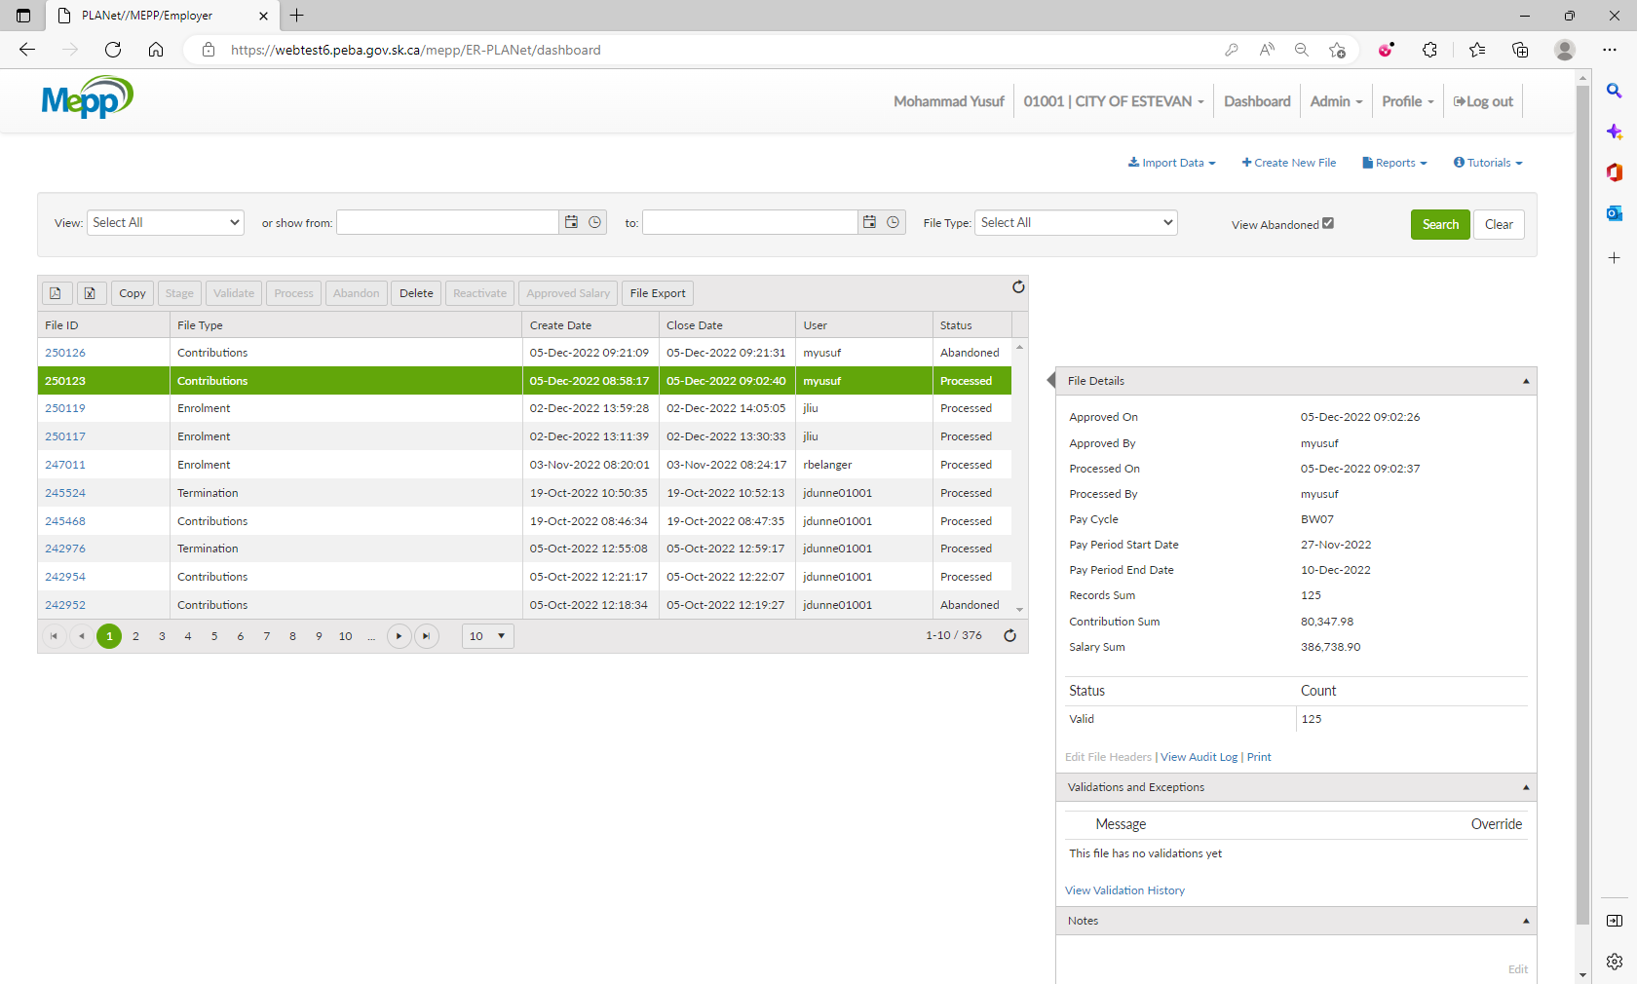

1. You have a file list on the dashboard.

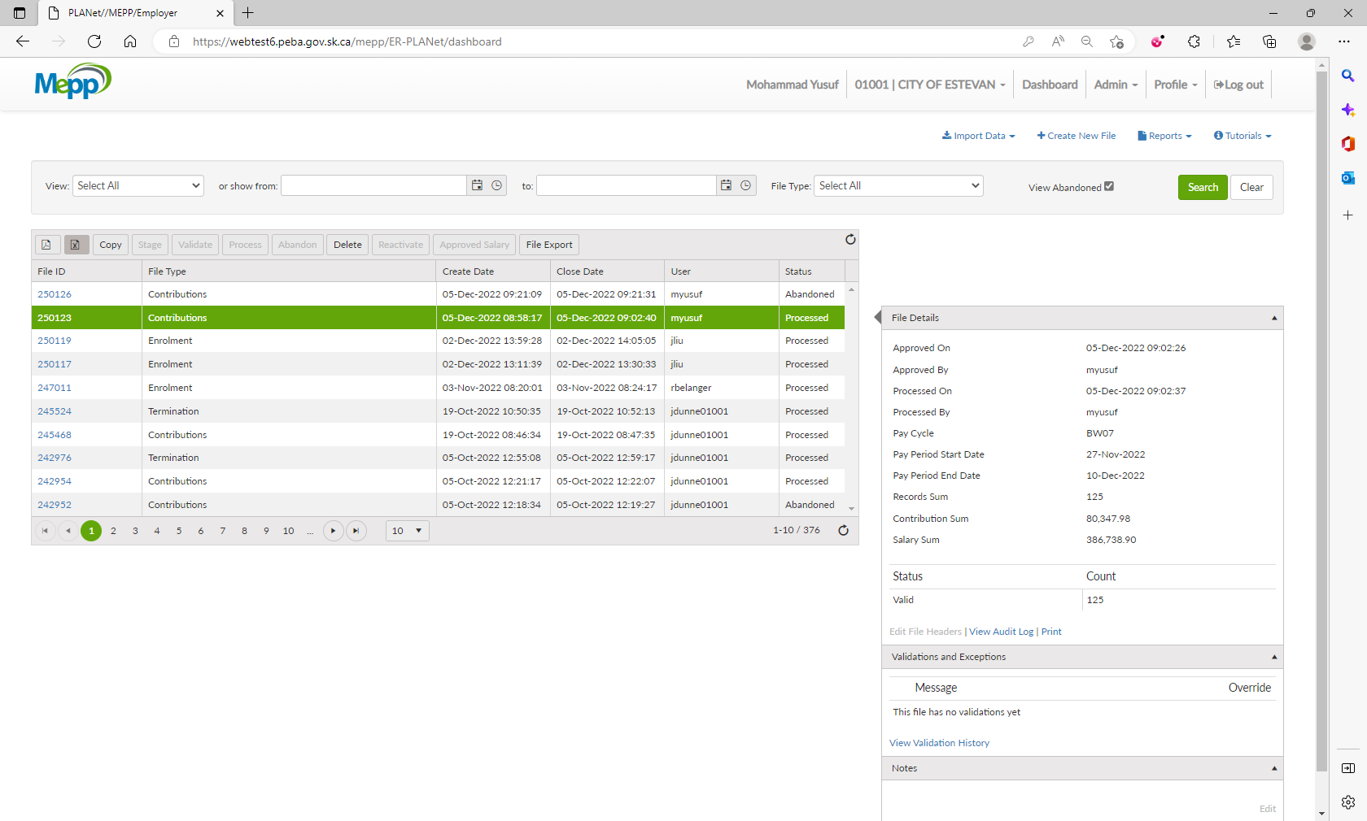

1. Click on Export to Excel.

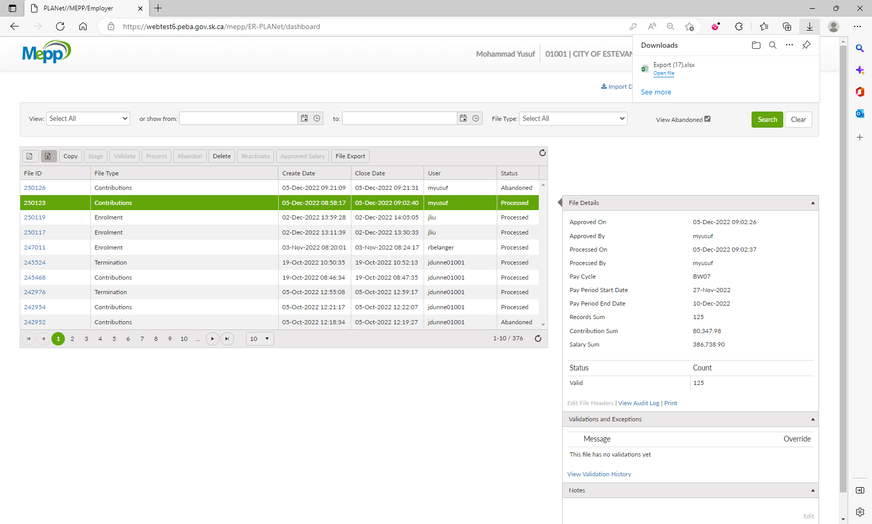

1. You will have a full files list in excel format.

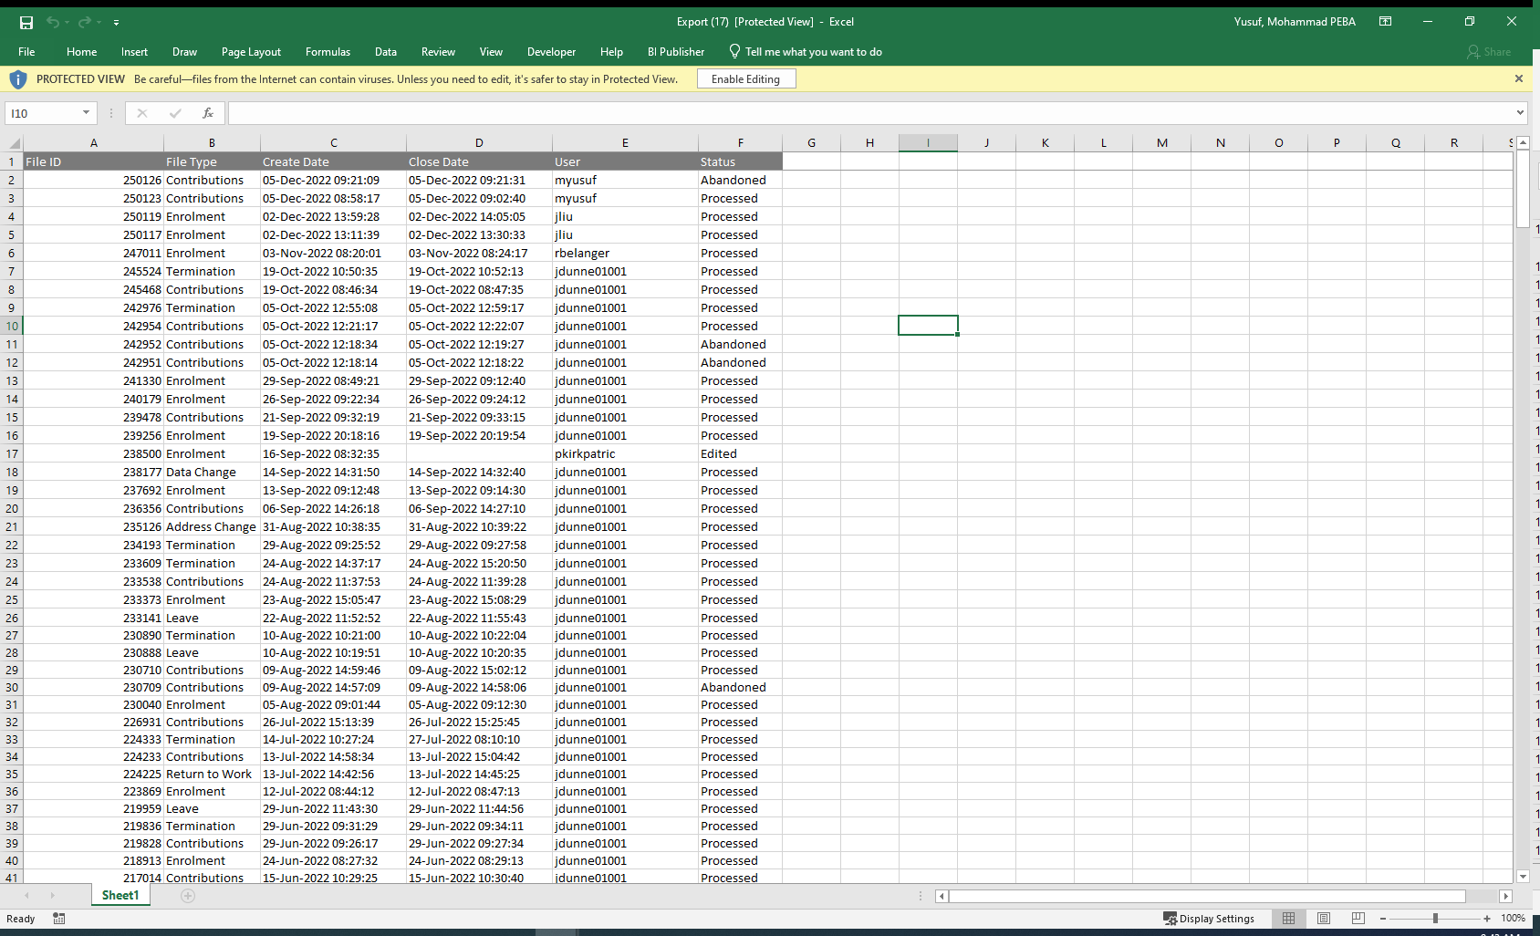

1. Click on Export to PDF.

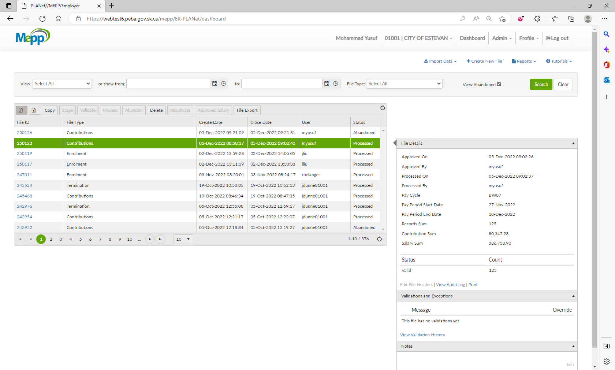

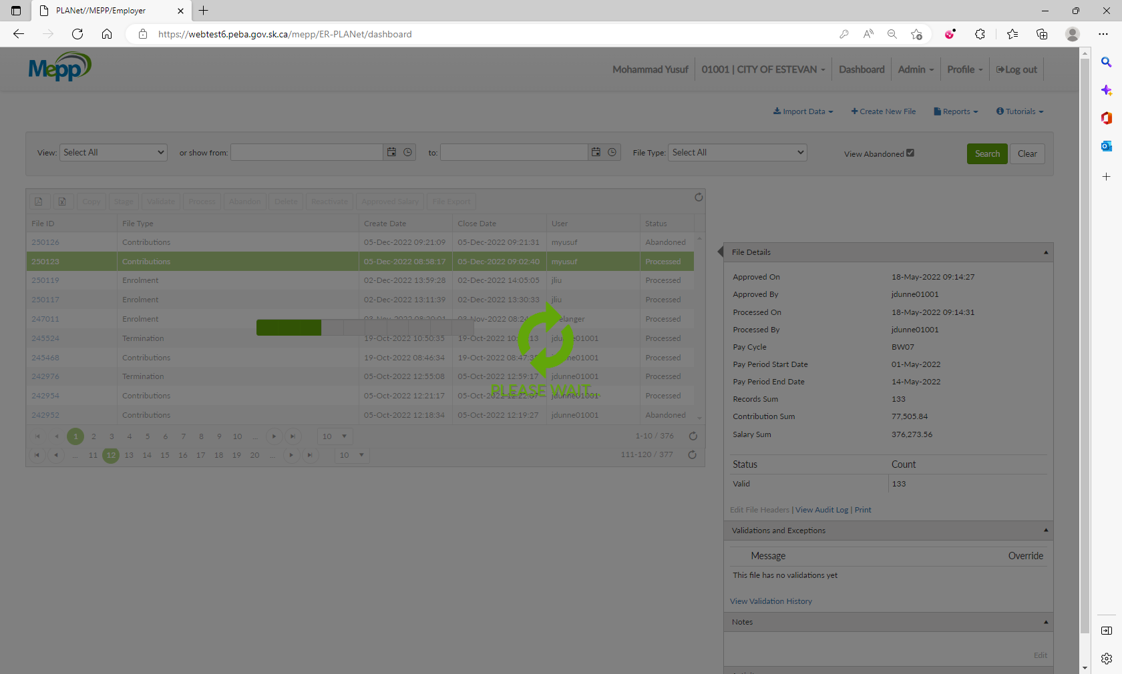

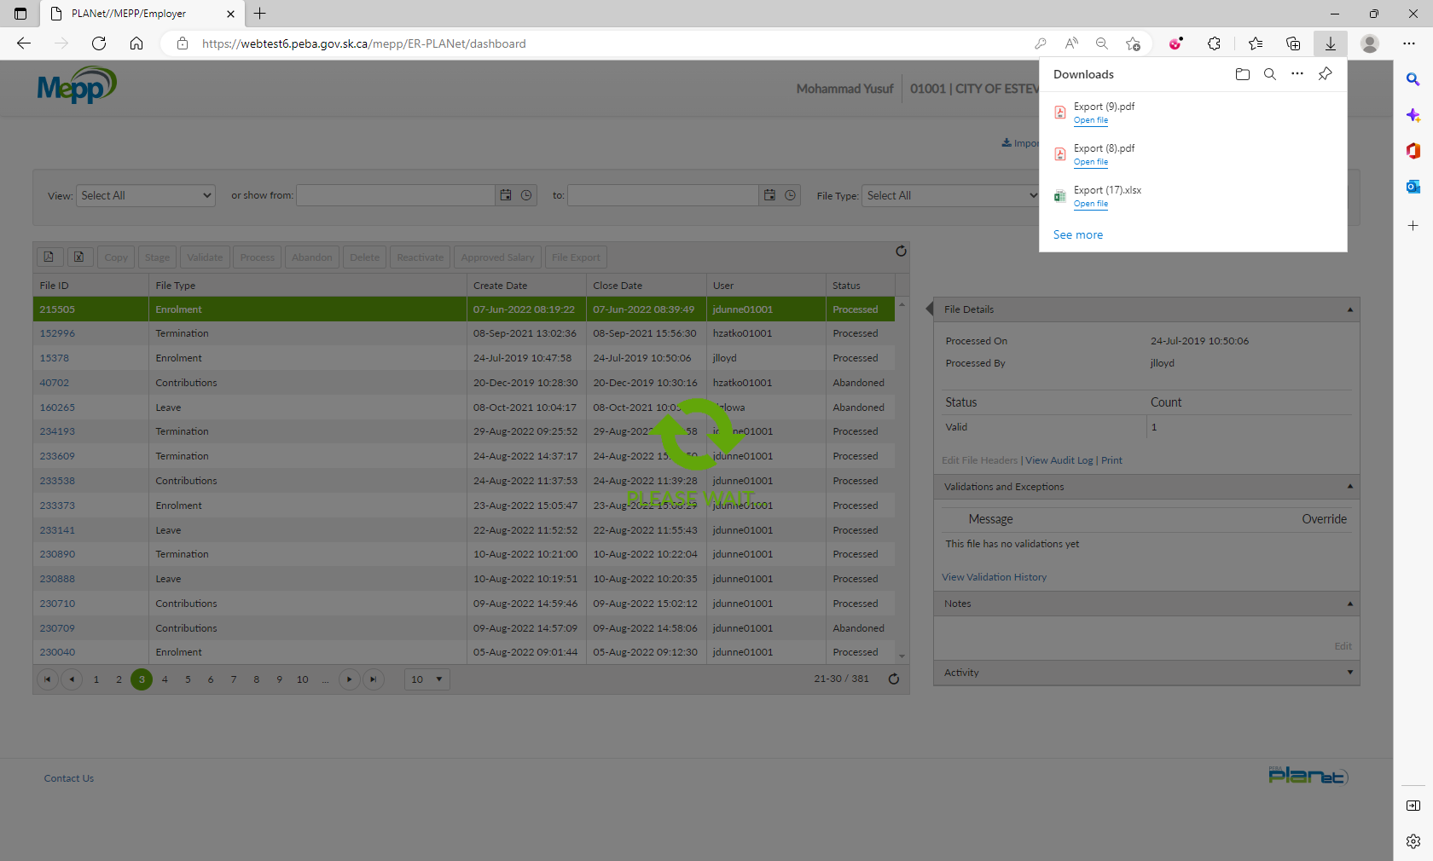

1. You will have a full files list in PDF format.

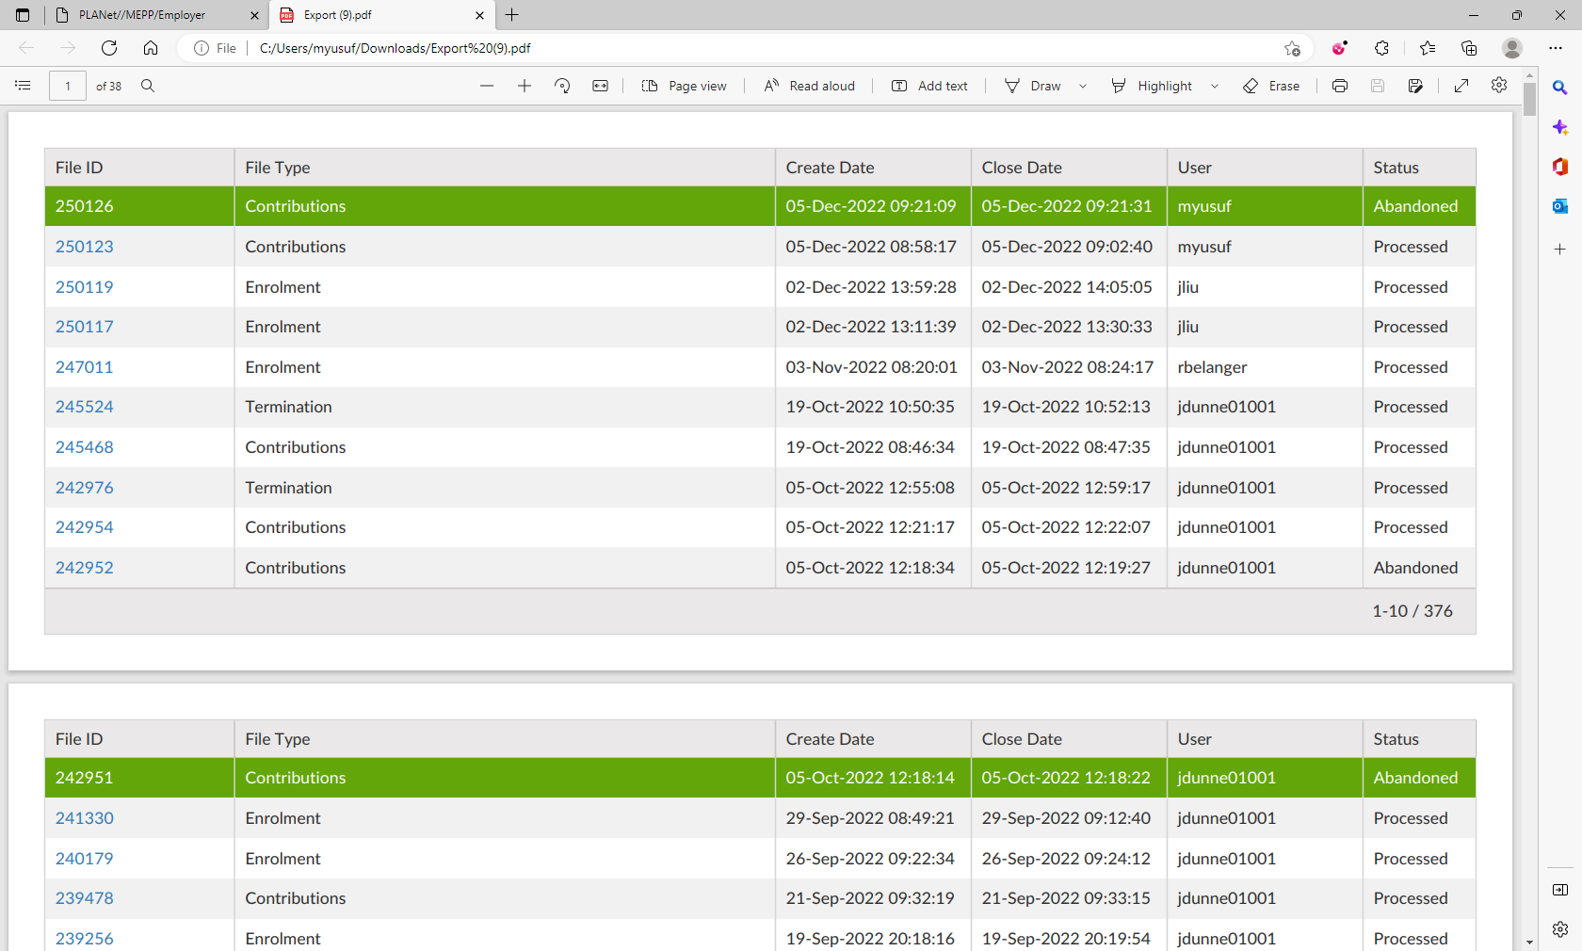

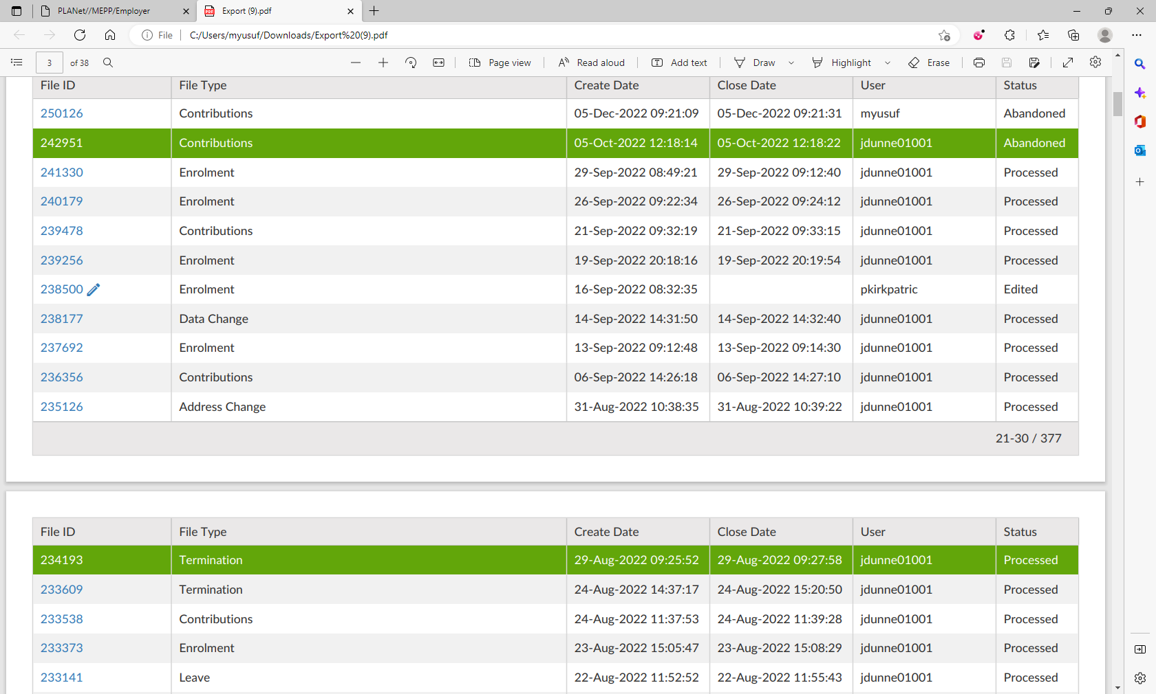

1. Now, click on the file ID.

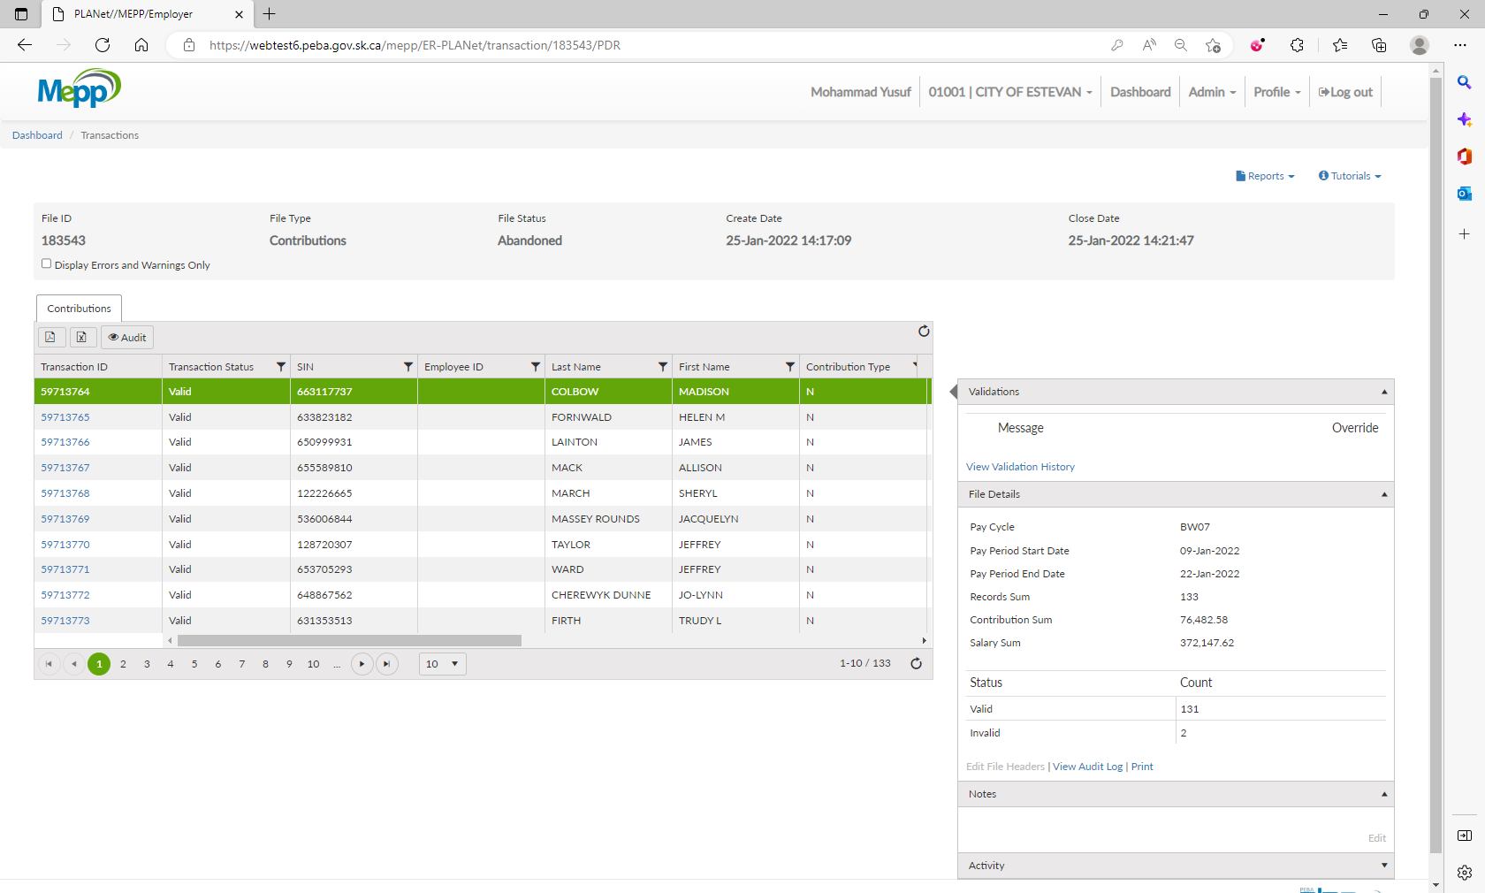

1. Click on Export to Excel.

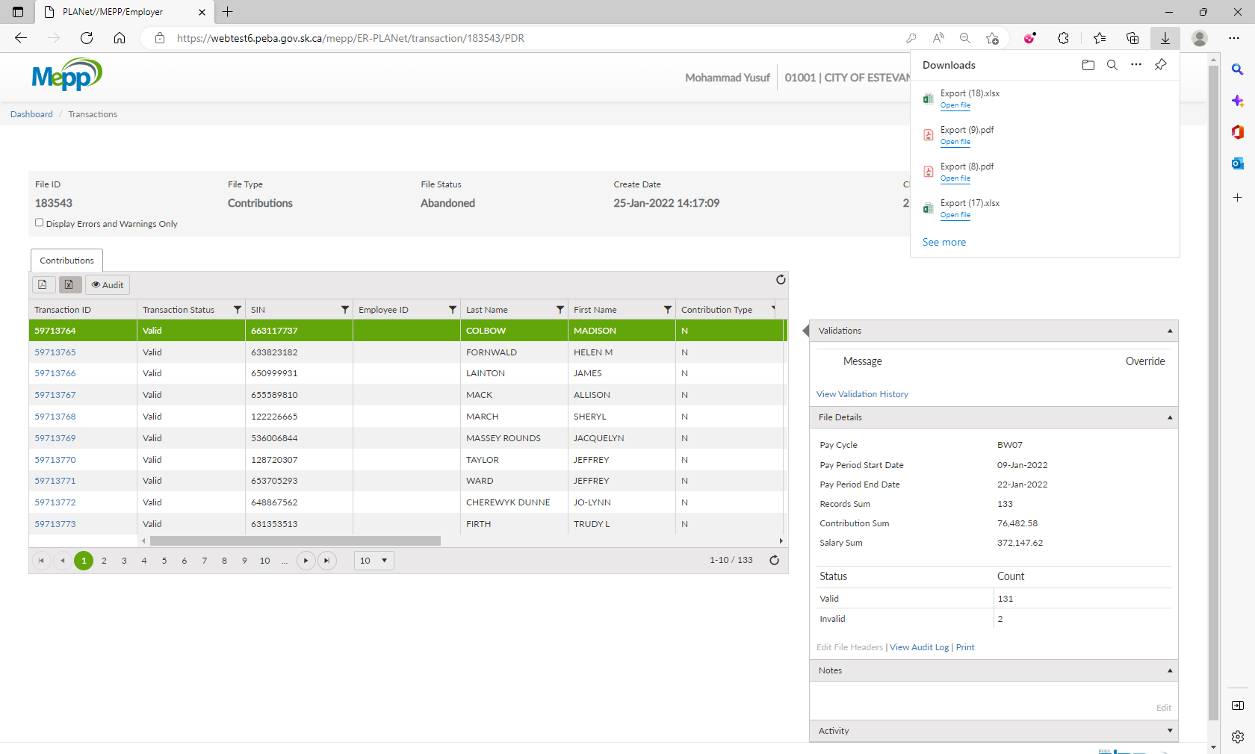

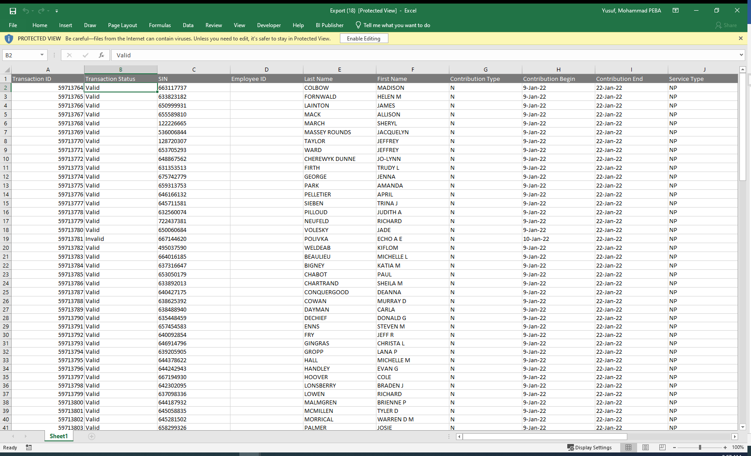

Count for total members is correct

1. Click on Export to PDF.

